1. 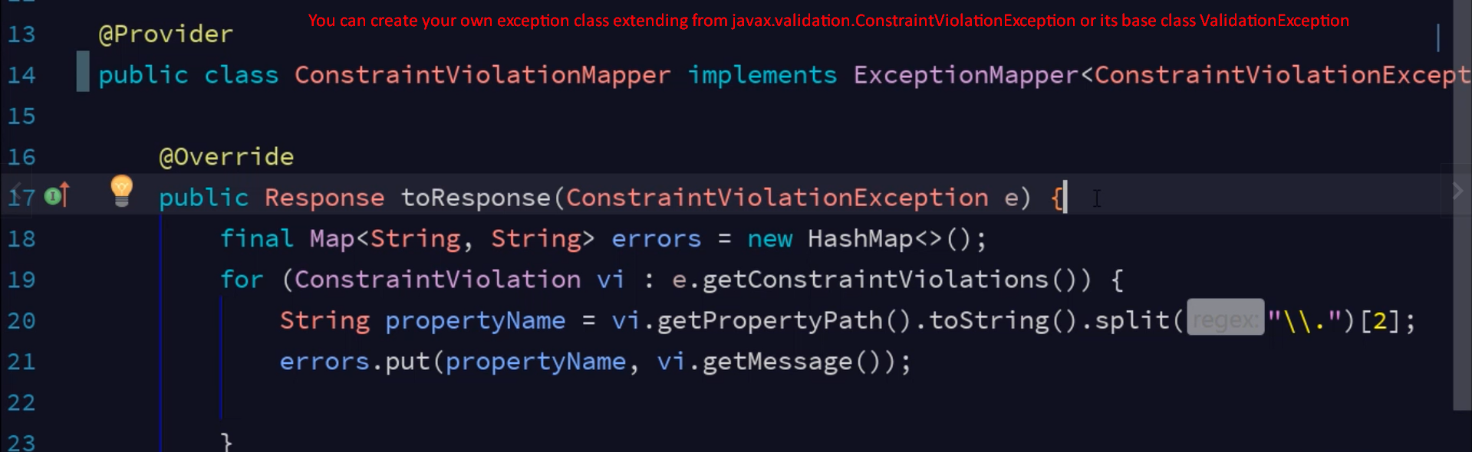
2. **Why would we create our own validation exception class?**
   1. To add some additional properties and then you create your own validation exception class object with those properties set so that then you can get those values in the above method ValidationException.toResponse();
   2. So extend either from ValidationException or ConstraintValidationException.